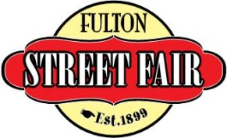

PARADE ENTRY FORM

DATE: Saturday June 21, 2014 TIME: 5:00 pm SPONSOR: William Woods University

THEME: Fulton Street Fair “Going Green in 2014”

AWARDS: All entries are eligible to win an award. The awards are as follows:
Grand Marshal Award - Best overall entry
The Woods Award - Best theme depiction
CJ’s Spirit Award – Most energetic entry

ENTRY INFORMATION:

Type of Entry (circle one): Band Church Non-Profit Business Other
Entry Name: ___________________________________________________________________
Responsible Person: _____________________________________________________________
Address: ______________________________________________________________________
City, State, Zip: _________________________________________________________________
Home Phone: __________________________ Work Phone: ___________________________
E-mail address: _________________________________________________________________
Number of Participants: Riding: ___________ Walking/Marching: ________________
Will you have music? No Yes (will it be live or recorded?)
Will you have animals? If yes, then please answer the following:
Type of Animals:______________ # Riding:______ # Walking:_______
Description of Entry: Please print legibly or attach typed info ______________________________________________________________________________
______________________________________________________________________________

AGREEMENT - As a prerequisite to participation in the Fulton Street Fair Grand Parade, the undersigned, as responsible party and representative for all participants in the aforementioned entry, knowingly and voluntarily assumes, on behalf of all participants, any and all risks inherent to participation in the Parade. Further, the undersigned waives on their behalf and all participants associated with this entry, any rights to claims against the Fulton Street Fair, their officials, sponsors, volunteers, agents or employees for any reason including, but not limited to, loss of life, bodily injury, property damage and/or loss that may be sustained as a result of participation in the Parade. The undersigned acknowledges receipt of, and agrees on their behalf and all participants associated with this entry, to abide by the rules and regulations for participation in the 2014 Grand Parade. Acceptance of this application and participation in the Grand Parade is strictly subject to the discretion of the Fulton Street Fair who reserves the right to reject any application for participation in the Grand Parade. Submission of a signed application shall not be deemed as granting any applicant the right to enter or participate in the Grand Parade.

Signature: _______________________________________________ Date: __________________

Return Application to: Mail: Fulton Street Fair Grand Parade OR Drop off: Chamber of Commerce Office
PO Box 341 409 Court Street
Fulton, MO 65251 Fulton, MO 65251

For information: Miranda Coleman, Parade Coordinator 573-220-8388 mirandacoleman09@yahoo.com
Lauren Nelson, Parade Coordinator lhume_141414@hotmail.com

www.fultonstreetfair.com

THIS SHEET TO BE TURNED IN
Fulton Street Fair
GRAND PARADE
Sponsored by William Woods University

RULES/INFORMATION

Application Deadline: All parade entry applications (this form) are due by June 14, 2013.

Date/Time of Parade: The parade will be held on Saturday, June 21, 2014. There is no rain date. Parade registration will begin at 3:45 p.m. on the campus of William Woods University. Entries must be checked in no later than 4:30 p.m.

Route: Procession will begin at 4:55 p.m. (see map)

Awarding of Prizes: Judging will take place prior to the parade at line-up starting at 4:30. To be eligible for an award, entries must show complete cooperation with all parade officials, as well as adherence to these parade rules. Failure to comply with any of these rules will result in disqualification. Awards will be awarded prior to start of parade. A magnetic sign will be displayed on the entry during the parade and surrendered at the completion of the parade.

Candy/Favors: No material, favors, candy, or any item may be thrown from the units along the parade route for the safety and enjoyment of the spectators. Candy favors and other items may be handed out along the parade route.

Motorized Units: All motorized units must maintain a speed of no more than five (5) miles an hour along the parade route. General liability and automobile liability insurance policies and combined single limit for bodily injury and property damage shall be carried for each motorized unit.

Animals: Animal units must provide a clean-up unit.

No alcoholic beverages will be permitted at parade line-up or during the parade. Any entry found with any alcoholic beverage will be removed from the parade immediately.

The Release of Liability Form (opposite side of this sheet) must be signed prior to proceeding in the parade. All entrants must have a complete list of names of all participants in their unit. Participants under the age of 18 will require the signature of a parent or guardian. Parade entrants are responsible for all vehicles connected with their entry, as well as for any person marching with their entry. No support vehicles will be allowed in the line up.

THIS SHEET TO BE RETAINED FOR YOUR RECORDS

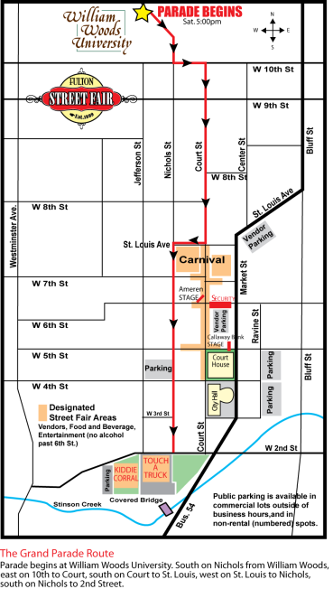
PARADE CONTACT
Miranda Coleman
573-220-8388
mirandacoleman09@yahoo.com

